

Winter 2018

Tuesday  January 23 | 7-8:30 p.m. | Umpqua Valley  Arts Center  Gallery Room | 1624 Harvard Roseburg  97471 | Program Planning
Tuesday  February 20 | 7-8:30 p.m. | Umpqua Valley  Arts Center  Gallery Room | 1624 Harvard  Roseburg  97471 | CASA
Tuesday  March 20 | 7-8:30 p.m. | Umpqua Valley  Arts Center  Gallery Room | 1624 Harvard  Roseburg  97471 | Topic:  How do we relate to each other without offending?

Greetings LWVUV Members,

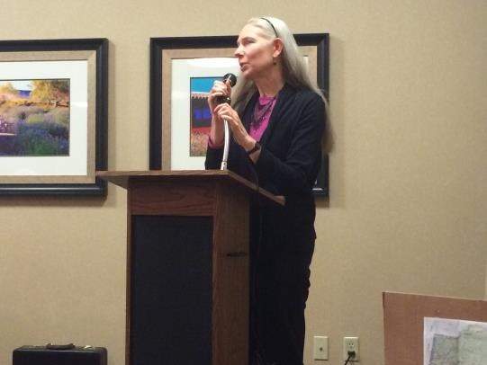
Here in Oregon, we are starting 2018 off with a vote. You have likely already received your ballot in the mail. Oregonians are voting Yes or No on Measure 101 in a special election. In keeping with our mission, our League has been working to educate voters. We held a voter education session on December 21. It was well-attended and we were happy with the next day’s News-Review coverage. Another session was held for residents of Riverview Terrace. Good questions were asked and answered.

If you are still unsure about M101, you will find more information later in this newsletter and online at lwvor.org, yesforhealthcare.org and various opposition websites.
Looking ahead, on January 23 we’ll hold our annual Program Planning meeting. Please mark your calendar and plan to attend. The LWVUS is asking for our input in advance of the National LWV Convention, to be held this summer in Chicago. All Leagues are asked to reaffirm support for the Campaign for Making Democracy Work® and to report on how they’ve used League positions in their work this past two years.
In addition, it’s the time when Leagues with an idea for a study can put forth their proposals. So far, the League of Women Voters Palos Verdes Peninsula/San Pedro has proposed that the LWVUS do a study of Artificial Intelligence (AI). As computers and robotics further pervade our lives, it might behoove us to have strong policies in place to control the ways they are used. Is this something League should take on? You’ll be able to help decide. I’ll be passing along some emails about this. They include links to further information about Artificial Intelligence which you may use to help you decide how important a League study on this topic may be during the 2018-2020 biennium.

Our Program Planning meeting is also an opportunity to refocus the efforts of our local League. We have several committees that have been inactive for a while, and new opportunities presenting themselves. Maybe it’s time to reimagine our efforts to support our Vision Statement which says, “We envision a democracy where every person has the desire, the right, the knowledge, and the confidence to participate”.
The month of May will bring the primary election season, and LWVUV may again be educating voters by holding candidate forums.
If the New Year has you energized and thinking about how you can be more active in LWVUV, please consider joining our Board as an at-large member. We meet on the first Wednesday of the month at 1:30 at 428 SE Chadwick. Or come to First Tuesday Talk Times. They happen from noon-1:00 at the same location. Bring your ideas and questions, and your friends. Non-members are welcome.
On February 20 please come and learn more about the CASA program (Court Appointed Special Advocates) from Katherine Elisar. This program is very important to children whose lives intersect the legal system in our county. This promises to be an inspiring presentation.
On March 20 we plan to bring you a program very relevant to our times. Inspired by the #MeToo campaign, we’ll explore the nuances of relating to each other without offending in this day and age.
Wishing you a happy and healthy 2018!
In League,
Jenny Carloni

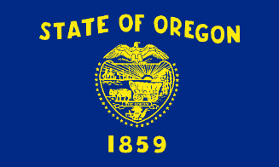 Measure 101
Much of the League’s time and energy has been occupied by M101 recently. While our educational events have not advocated for or against M101, the LWVOR has taken a public position urging a Yes vote on M101. You will see that in the state Voters’ Pamphlet. Sometimes people are confused by the way the League “wears two hats”. We educate and we advocate. But we do those things separately.
This is the League’s National Position on Health Care (LWVUS)
Promote a health care system for the United States that provides access to a basic level of quality care for all U.S. residents and controls health care costs.
At the state level, the League (LWVOR) supports the Coordinated Care Organization model. These CCOs deliver health care to low-income Oregonians, through the Oregon Health Plan (OHP) which is Oregon’s Medicaid program.

The following is from LWVOR’s Voters’ Guide, available in its entirety at lwvor.org

BACKGROUND:
The Oregon Health Plan (OHP)—Oregon’s Medicaid program—covers about a million people, including low-income children, seniors and people with disabilities.

In 2014 the federal government’s Affordable Care Act provided federal funds to Oregon and other states to expand Medicaid coverage. As of 2017, this resulted in OHP providing coverage to 350,000 previously uninsured low-income Oregonians. Medicaid expansion includes adults not covered by an employer’s plan who earn up to 138% of the federal poverty level. Initially, the federal government paid 100% of these expansion costs. However, starting in 2017, Oregon was required to pay 5% of the expansion costs in order to release federal funds to cover the Medicaid Expansion coverage. Oregon’s required percentage contribution will increase in 2018 to 6%, 7% in 2019, and its share will be capped at 10% in 2020 and beyond.

By the end of 2016 there was a $1.6 billion budget shortfall for Oregon’s mandated programs. Starting in January 2017, the Oregon Legislature worked with stakeholders on HB 2391 to fund the Oregon Health Plan for another 2 years to ensure that this shortfall did not cause approximately 350,000 Oregonians to lose insurance. It was signed into law on July 3rd, 2017, passed by a three-fifths majority vote (Senate: 20 to 10, House 36 to 23).

HB 2391 funds the state’s cost sharing obligation by imposing temporary (two-year) additional assessments on hospitals and health insurance companies. (Since the Medicaid healthcare provider organizations are the primary beneficiaries of federal Medicaid funding, such assessments are used in 49 states to fund health care. Oregon has used similar assessments since 2003; prior to 2014, an assessment on insurers funded Oregon’s Healthy Kids Program.)

Part of the revenues will be used as “reinsurance” for individual policy insurers, as a backstop for extraordinarily large claims. The intention is that individual market insurers will be able to lower their premiums. If this measure passes, the assessments on some hospitals will be approved, subject to the approval date by the Centers for Medicare and Medicaid Services (CMS) of the federal Department of Health and Human Services.

Approval of Ballot Measure 101 will retain HB 2391 in its entirety… (Read more at lwvor.org)

The following is compiled from other sources.

Why are we voting on Measure101 and what are the results of a “yes” or “no” vote?
Three Oregon legislators—Sal Esquivel (R) Medford, Cedric Hayden (R) Roseburg, and Julie Parrish (R) West Linn— were unhappy with the funding mechanism (temporary two-year additional assessments on hospitals and health insurance companies) provided by HB 2391. They sponsored a referendum, collecting enough signatures to put it on the ballot as M101, essentially giving the voters veto power over the work of the legislature. They have not proposed alternative funding mechanisms, but say the legislature should be forced to “try again”.

A “yes” vote would keep the HB 2391 funding mechanism and a “no” vote would repeal it.

If M101 fails, the legislature may need to cut funds from other programs and use them to fund Medicaid, or cut Medicaid.

Oregon must pay the 6-10% cost of Medicaid expansion, in order to receive the 94-90% paid with federal funds, affecting health care for about 350,000 low-income Oregonians.

In Douglas County, about 12,000 people would lose access to the health insurance and health care they gained through Medicaid expansion.

Health care providers and insurance companies are willing to pay for the funding mechanism. They advocate a “Yes” vote. The Medicaid expansion has been good for them financially. When people have health insurance, fewer end up using the emergency room for their health care. The high cost of emergency room care, unreimbursed to the health care provider if the patient has no insurance, drives costs up for everyone.

More information is available on the lwvor.org website, the VOTE411.org website, and other sites online.

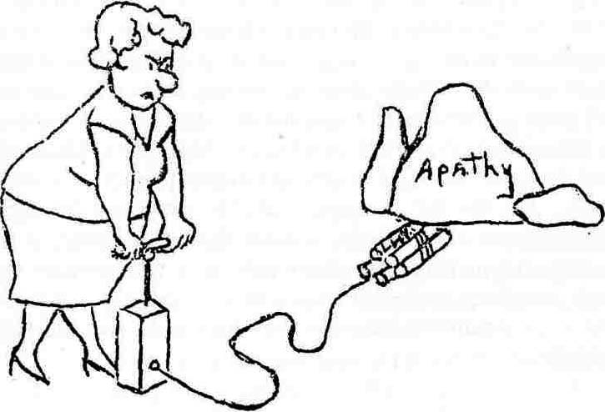
The League’s Program Planning Explained

Each year the national League encourages each local League to hold a “Program Planning” meeting in January to find new ideas for studies and to take another look at what we have already done.

As times change, we may need new studies so that we can create positions on which we can advocate with one voice on all three levels - local, statewide, and national.

Local Leagues, state Leagues and the national League can suggest studies. Each League must consider their League’s capacity before choosing to conduct a study. Studies are usually two years long. Research is done the first year. During the second year, peer review is sought, editors edit, and a report is completed and distributed to other Leagues. It’s a group experience, and not just for one or two people!

We try our hardest to be impartial as we study, and to cover all the aspects, positive and negative. Visit https://sites.google.com/a/leagueofwomenvoters.org/clearinghouse/to see many of the studies undertaken and completed by local Leagues across the country. We can also choose to vote for “concurrence” based on another League’s study, meaning our League also agrees with that study and chooses to adopt it for our use.

After a study is completed, a League holds a “consensus” meeting to determine positions, generally very broad statements that we can use, for example, when testifying at the Capitol or writing an argument for the local newspaper. See state League positions here http://lwvor.org/home/take-action/lwv-oregon-positions/. You can also find national positions on the lwv.org site.

At your January 23rd meeting, we will discuss the national League’s Campaign for Making Democracy Work® (listed below) among other topics. Be sure to attend!

- Voting Rights
- Improving Elections
- Campaign Finance/Money in Politics
- Redistricting

Submitted by Robin Wisdom


DATE SET FOR 2018 GARDEN TOUR

Mark your calendars for Saturday, June 16, 2018, the date of our seventh annual self-guided Garden Tour.

Tickets go on sale May 1 — Just in time for Mother's Day gifts! Here are more details:

What: One day, self-guided tour of five lovely gardens in close proximity to each other.

Where: Garden Valley area.

Time/Date: 10 am - 5 pm

Price: $15 ea. (same as last year)

PLEASE HELP!
GARDEN TOUR KEEPS THE LEAGUE WORKING!
Our annual Spring Garden Tour is more than a much-anticipated local event. The money we raise from the tour funds
the non-partisan political activities that you value, from copying and disseminating voter material to room
rental expenses for voter forums on upcoming ballot measures.

Please help. We need extra hands to pull off our Garden Tour. No experience necessary! Specifically, volunteers are needed for two kinds of Tour Tasks:


"Poster Posse" — Since advertising is so expensive, we mostly publicize our tour with posters. Please sign up to be a member of our "Poster Posse." Poster Posse members spend one afternoon in April going out — in teams of two — to distribute our colorful Garden Tour poster to local businesses and organizations.

"Garden Hosts" — We also need volunteers, on June 16, to sit at the host table for each garden and check-off tickets, as people arrive. We have half-day shifts, and we provide the card tables and chairs. This is fun! Hundreds of people go through our gardens, so you'll see old friends and meet new ones.

To sign up as a member of our "Poster Posse" or as a "Garden Host," e-mail Connie Page at rkreofsky@gmail.com. Connie will contact you re: a "coffee and snack" meeting in the spring, where everyone will receive info, details, and our thanks!

Advocate for Cleaner Air & Support Clean Energy Jobs Legislation

By Cindy Burgess, President, LWV of Marion and Polk Counties

Cleaner Air— You are urged to send personal testimony to the Oregon Department of Environmental Quality concerning their proposed Cleaner Air Oregon rules. They have extended the deadline to January 22 at 4:00 p.m., so if you have not yet looked at the proposed rules and written your comments, you still have time.

LWVOR wants us to emphasize that the risk ceiling is too high and that rules should be grounded in science, informed by data, and health-based. For more information, look at the rules at cleanerair.oregon.gov. Send your comments to Joe Westersund, Oregon DEQ, westersund.joe@deq.state.or.us.

Price Carbon Emissions—LWVOR joined the Renew Oregon Campaign Coalition in 2015 to support legislation to price emissions. At the LWVUS Convention 2014, the following resolution was adopted by a large margin: “The LWVUS should support a price on carbon emissions that will increase in stages, as part of an overall program to improve energy efficiency and to replace fossil fuels with renewable energy, fast enough to avoid serious damage to the climate system.”

LWVOR has supported legislation each session to reduce greenhouse gas emissions. The Clean Energy Jobs legislation would establish a program to cap climate pollution, price all qualified greenhouse gas emissions under the cap, and invest the proceeds in clean energy, while addressing the needs of vulnerable communities and investing in training workers for new, growing opportunities in a clean-energy economy. The Clean Energy Jobs legislation is scheduled for the 2018 legislative session and is based on SB 1070 from the 2017 session.

Write your legislators and also write your county commissioners and city mayors and ask them to support the legislation. For more information look at reneworegon.org.


SAVE the DATE:
February 20, 2018

We all agree that children deserve to live in a safe home. They should have adequate food, clothing, shelter & be nurtured by a caring adult. In Douglas County there are children whose basic needs are not being met & who are often living in dangerous situations.
As of December 28, 2017, there were 590 children in foster care in Douglas County. Of those, 281 were being served by a professionally trained volunteer CASA, whose sole responsibility is to advocate for the best interests of the child.
Please join us Feb. 20th at 7p.m. to hear Katherine Elisar, program director of CASA of Douglas County inform us about the role of a Court Appointed Special Advocate.
You do not need to be interested in becoming a volunteer CASA to attend. This is a League educational meeting open to all.

LWVUV Board Members 2017-2018
President: Jenny Carloni
Secretary: Julee Wright
Treasurer: Robin Wisdom
Membership: Sally McKain
Garden Tour: Nancy Farris
Member at Large: Tina Arredondo
Member at Large: Sandra Huffstutter

Yes! I want to join the League__as a renewing member __as a new member.

I am enclosing:
____ $60 for Individual Membership
____ $90 for two Household Members
____ $30 for Student or Limited Income Member
____ $ _____ Contribution to LWVUV budget (not tax-deductible)
____ $ _____ Total to LWVUV (not tax deductible)
____ $ _____ Contribution to LWVOR (tax deductible; requires separate check to LWVOR)
(LWVUV can use these funds for educational projects or Per-Member-Payment to LWVUS)
Please mail your check(s) and form to Treasurer Robin Wisdom, 1260 Arcadia Drive, Roseburg OR 97471
For more information, contact President Jenny Carloni, 541-672-1914, jennifer.carloni@gmail.com or
.
.

